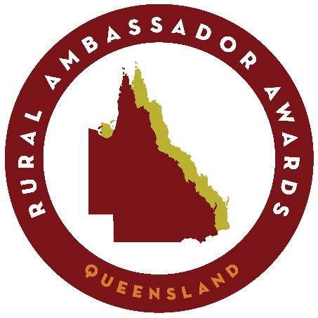
ENTRY FORM
Show Dates and Sub Chamber Finals locations / dates can be found on the Queensland Ag Shows Website:

www.queenslandshows.com.au/show-dates
Coordinator USE ONLY

Local Show:
ο WINNER ο Runner Up

Sub Chamber:
- WINNER ο Runner Up

- State Invitation Sent

PROCESSING INSTRUCTIONS:

All entrants must complete an Entry Form and submit all required documents and photo prior to Local Agricultural Society Judging Date. This form will be used for Local and Sub Chamber competitions.

LOCAL SHOW – The Show Society Secretary or designated coordinator is to forward the Local Show Winner and Runner Up Entry Form & required documents to Sub Chamber Secretary for processing within 14 days of the competition conclusion. Please keep a copy for your records.

SUB CHAMBER FINALS – The
Sub Chamber Secretary is to forward Sub Chamber Finals Winner and Runner up Entry Form, required documents & photo to the Queensland Ag Shows Head Office competitions department within 14 days of competition conclusion to qualify for State Finals. competitions@queenslandshow s.com.au

Please complete information below in Clear CAPITAL LETTERS.
Competitor Information
Nominating Society ___________________________________________________
Full Name ____________________________________________________________
Email _________________________________________
Date of Birth __ / __ / ____ Age (at 1ST of May) ______
Mobile _________________________ Home Phone (07) ____________________
Street Address ______________________________________________________
Suburb _________________________________________ Postcode _________

Shirt/Blouse Size (State Finals requirement) _________________________

Sub Chamber ________________________________________________________

Entrant Declaration:

attached a portrait photograph  attached completed questionnaire | attached a covering letter  read & understand criteria

DISCLAIMER:
I have read and understand the Rural Ambassador Nomination Criteria, Regulations and By- laws and agree to be bound in all respects by these Rules & By-Laws of QCAS. I also consent and agree QCAS and show societies have the right to take or use photographs of me (and/or my property) and use the photos in any and all marketing and media worldwide including online, now or in the future.
False or misleading information given by the entrant may lead to disqualification from this event and for the duration of the competition.
_ _ _ _ Entrant Signature Date Agricultural Show Representative Signature Date

_ _ _ Sub Chamber Representative Signature Date (Only required for Winner of Local Show)

ENTRANT QUESTIONAIRE
Full Name ____________________________________________________________
- Please describe any previous Agricultural Show involvement (including stewarding, exhibiting and general responsibilities during the show or other activities),or should you have no previous experience please describe you understanding of Agricultural Shows:
(150 words or less)

- Please indicate any Agricultural related interests (e.g. growing crops, breeding/showing, agronomy, etc.):
(100 words or less)

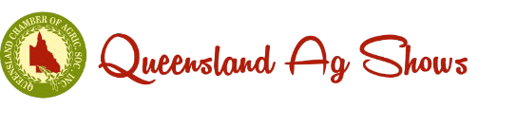
- Please describe your Personal Achievements to date:

(150 words or less)

- Please provide details of any agricultural related skills you may consider relevant:
(150 words or less)

- Please describe your ambitions and inspirations:
(150 words or less)

- Please describe your local community involvement:
(150 words or less)

- Please provide a short overview of your employment history and associated responsibilities:
(150 words or less)

- Please provide a short overview of your educational details (including TAFE Courses etc.):
(150 words or less)

- Please provide details of any hobbies and other interests:
(150 words or less)

- Why do you want to be a Rural Ambassador:
(150 words or less)

Page 6 of 10

- How do you believe your selection as a Rural Ambassador could assist you and your Agricultural Society:
(150 words or less)

- Please describe any suggestions you may have on ways to improve your local Show:
(150 words or less)

Page 7 of 10

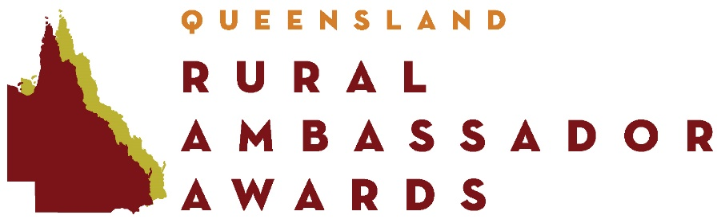

Name
Show Society
Sub-Chamber
Date of Birth
Medicare Number

Dietary Requirements:
E.g. Vegetarian, Gluten Free ____________________________________________________

Heart Problems | yes/no
Respiratory Problems | yes/no
Allergies | yes/no
Travel Sickness | yes/no
Blood Pressure | yes/no
Operations | yes/no
Epilepsy | yes/no
Recent illness Injections | yes/no
E.g. Tetanus | yes/no
Drugs required | yes/no
Phobias | yes/no
Diabetes | yes/no
Other:

Emergency Contact
Name
Phone Number
Mobile

____________________________ ______________________
Signed Date

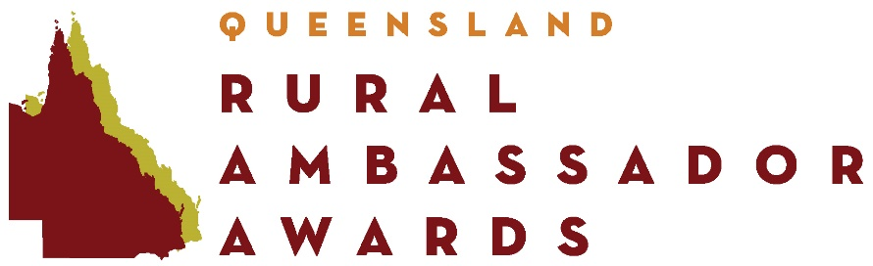

Eligibility
RULES OF COMPETITION

- The award is open to persons born in Australia or naturalised Australians permanently residing in Queensland.
- Entrants must be permanent residents of Australia who have resided in Queensland for a minimum of three (3) months immediately prior to nomination, or if resident near a state border can show they are an active working member of their nominating affiliated Agricultural Society.
- Entrants must be aged 20 and less than 30 years as at 1 May in the year of the competition.
- The award is opened to both males and females either single or married.
- Immediate family members of affiliated Agricultural Societies and QUEENSLAND AG SHOWS committee members and staff are eligible to enter provided they;
  - Declare a pecuniary interest, and
  - Are not involved in any discussion regarding the result during the competition
- Previous state and national winners are not eligible to re-enter the competition.
- State finalists (excluding the winner) are eligible to re-enter the competition after a period of two (2) years. Two state finals must have passed in this period
- Affiliated Agricultural Society winners are eligible to compete in Sub-Chamber finals. In the event that the winner becomes ineligible or unavailable the runner-up becomes eligible to represent the Agricultural Society.
- The Sub-Chamber finals winner is eligible to compete in the State Final. In the event that the Sub-Chamber winner becomes ineligible or unavailable the runner-up becomes eligible to represent the Sub-Chamber.
- The State final winner is eligible to compete in the National final. In the event that the winner becomes ineligible or unavailable the runner-up becomes eligible to represent Queensland.

Local Show Competition
- Entrants must be nominated by an affiliated Agricultural Society to be eligible to enter a Sub-Chamber final.

Criteria
- Entrants should be actively involved, or demonstrate a readiness to become actively involved in, their local Agricultural Society and Agricultural Show. They should also be knowledgeable about current rural issues pertaining to their local area, Queensland and Australia and have a strong affiliation towards agriculture.
- Tertiary qualifications are not a prerequisite for the Rural Ambassador Award and will have no influence in the selection process. The Award seeks to attract all young rural people who symbolise the rural spirit – people with vitality, who are forward thinking and with a passion for the land and local Agricultural Shows.

Entry Forms
- At Local, Sub-Chamber and State level all entries must include a completed entry form, accompanied by a completed questionnaire, recent photograph (in high resolution electronic format) and a covering letter. Failure to provide the above documentation will deem the entry invalid.

Awards
- Prizes awarded to Rural Ambassadors are not transferable. All prizes are subject to change without notice and when the prize is a voucher or bursary the voucher and bursary will expire at it’s expiration date.

State Finals
- State Finalists should be available for a minimum of three (3) full days to participate in all activities associated with the State Final held during the Royal Queensland Show. Should there be any concerns with timeframes the State Coordinator is to be advised immediately.
- State finalists must participate as part of the group during the entire itinerary. If unable to do this they must withdraw from the contest and the runner-up will be invited to take their place.
- State Winner and Runner Up are required to commit to a further three (3) days attendance at the Royal Queensland Show as per the Rural Ambassador Itinerary. Should there be any concerns with timeframes the State Coordinator is to be advised immediately.
- Travel to and from Brisbane and whilst in Brisbane is the responsibility of Finalists. This may be subsidised by the nominating Sub-Chamber and / or Agricultural Society (at their discretion).
- State Finalists must accept that any behaviour that will bring disrepute to these Rural Ambassador Awards and is deemed inappropriate by the organising committee, prior to or during the State Finals, may forfeit their right to participate.
- State Finalists will be asked to adhere to a dress code, information is released directly to the finalist.

Rural Ambassador Rules - V3
Page 10 of 10

